Figure captions.

**Fig. 1** Arthropod biomass (total grams per branch) with pooled comparisons between native plants and each invasive plant species. Biomass is reported as total wet mass collected from branches. Mean ± SEM is plotted, with levels of significance illustrated for native versus each invasive plant species using grouped, planned contrasts.

**Fig. 2** Effect size of bird exclusion treatment showing pooled comparisons between native plants and each invasive plant species. Bird exclusion effect size reported as Log-Response Ratios (LRR), in which positive values > 0 indicate a significant reduction in arthropod abundance in response to bird predation. Mean ± SEM is plotted, with levels of significance illustrated for natives versus invasive plant species using grouped, planned contrasts.

**Fig. 3** Total % nitrogen for insect herbivores on bird-exclusion branches. Nitrogen content is measured as the total molecular mass of elemental nitrogen relative to total mass of a single sample from an experimental host-plant branch. Mean ± SEM is plotted, with levels of significance illustrated for natives versus invasive plant species using grouped, planned contrasts.

**Fig. 4** Total % nitrogen for true spiders on bird-exclusion branches. Nitrogen content is measured as the total molecular mass of elemental nitrogen relative to total mass of a single sample from an experimental host-plant branch. Mean ± SEM is plotted, with levels of significance illustrated for natives versus invasive plant species using grouped, planned contrasts.

Fig. 1.

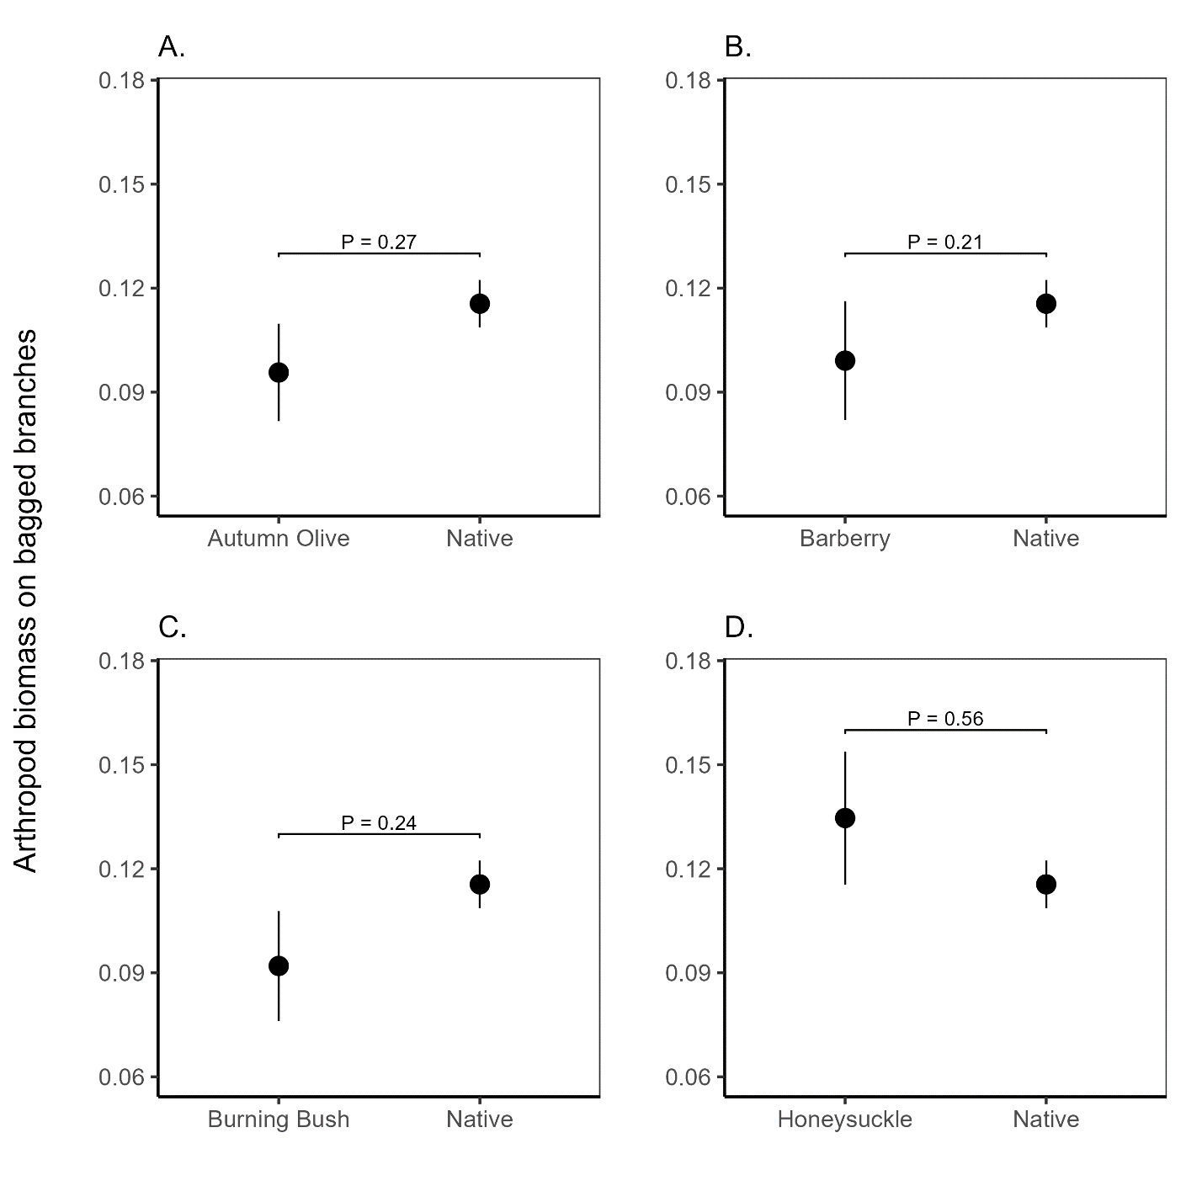

Fig 2.

Fig 3.

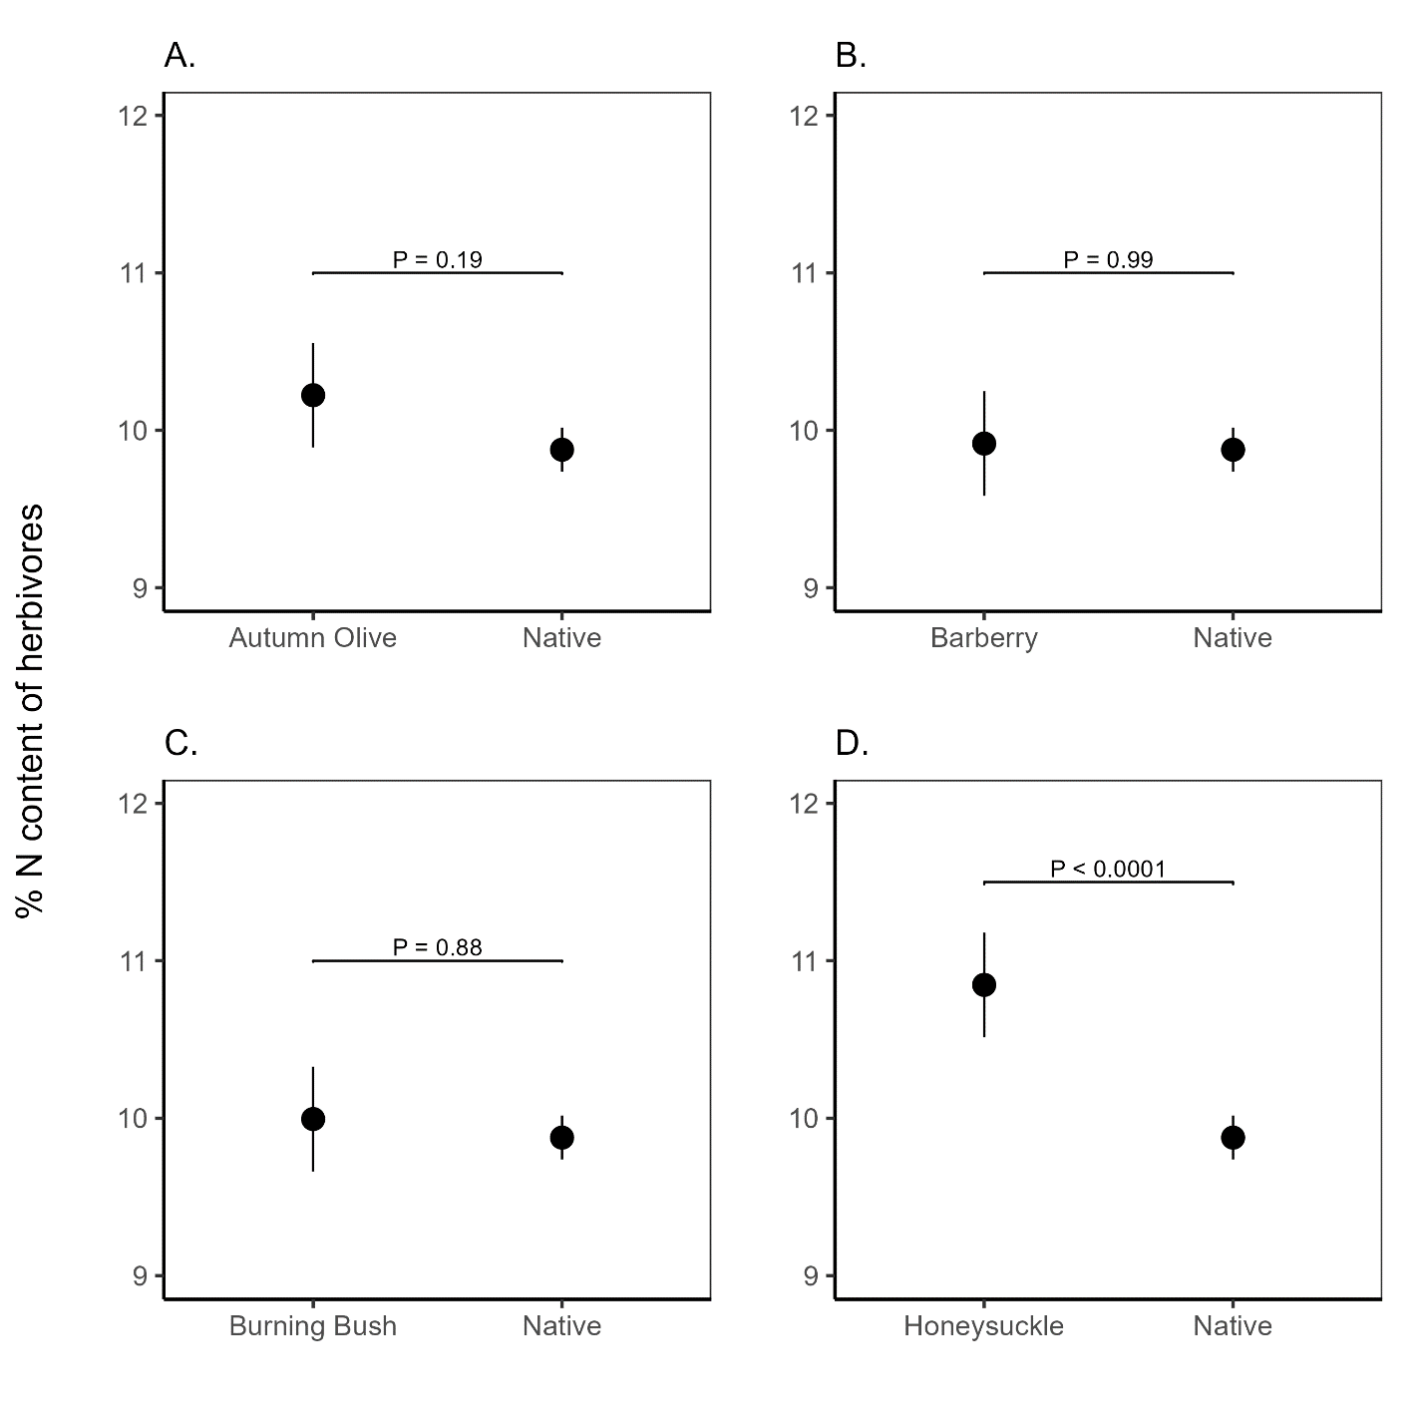

Fig 4.

